Facebook link:

<https://www.facebook.com/EternalEgyptDigitalWorld>

our insights for 10 days:

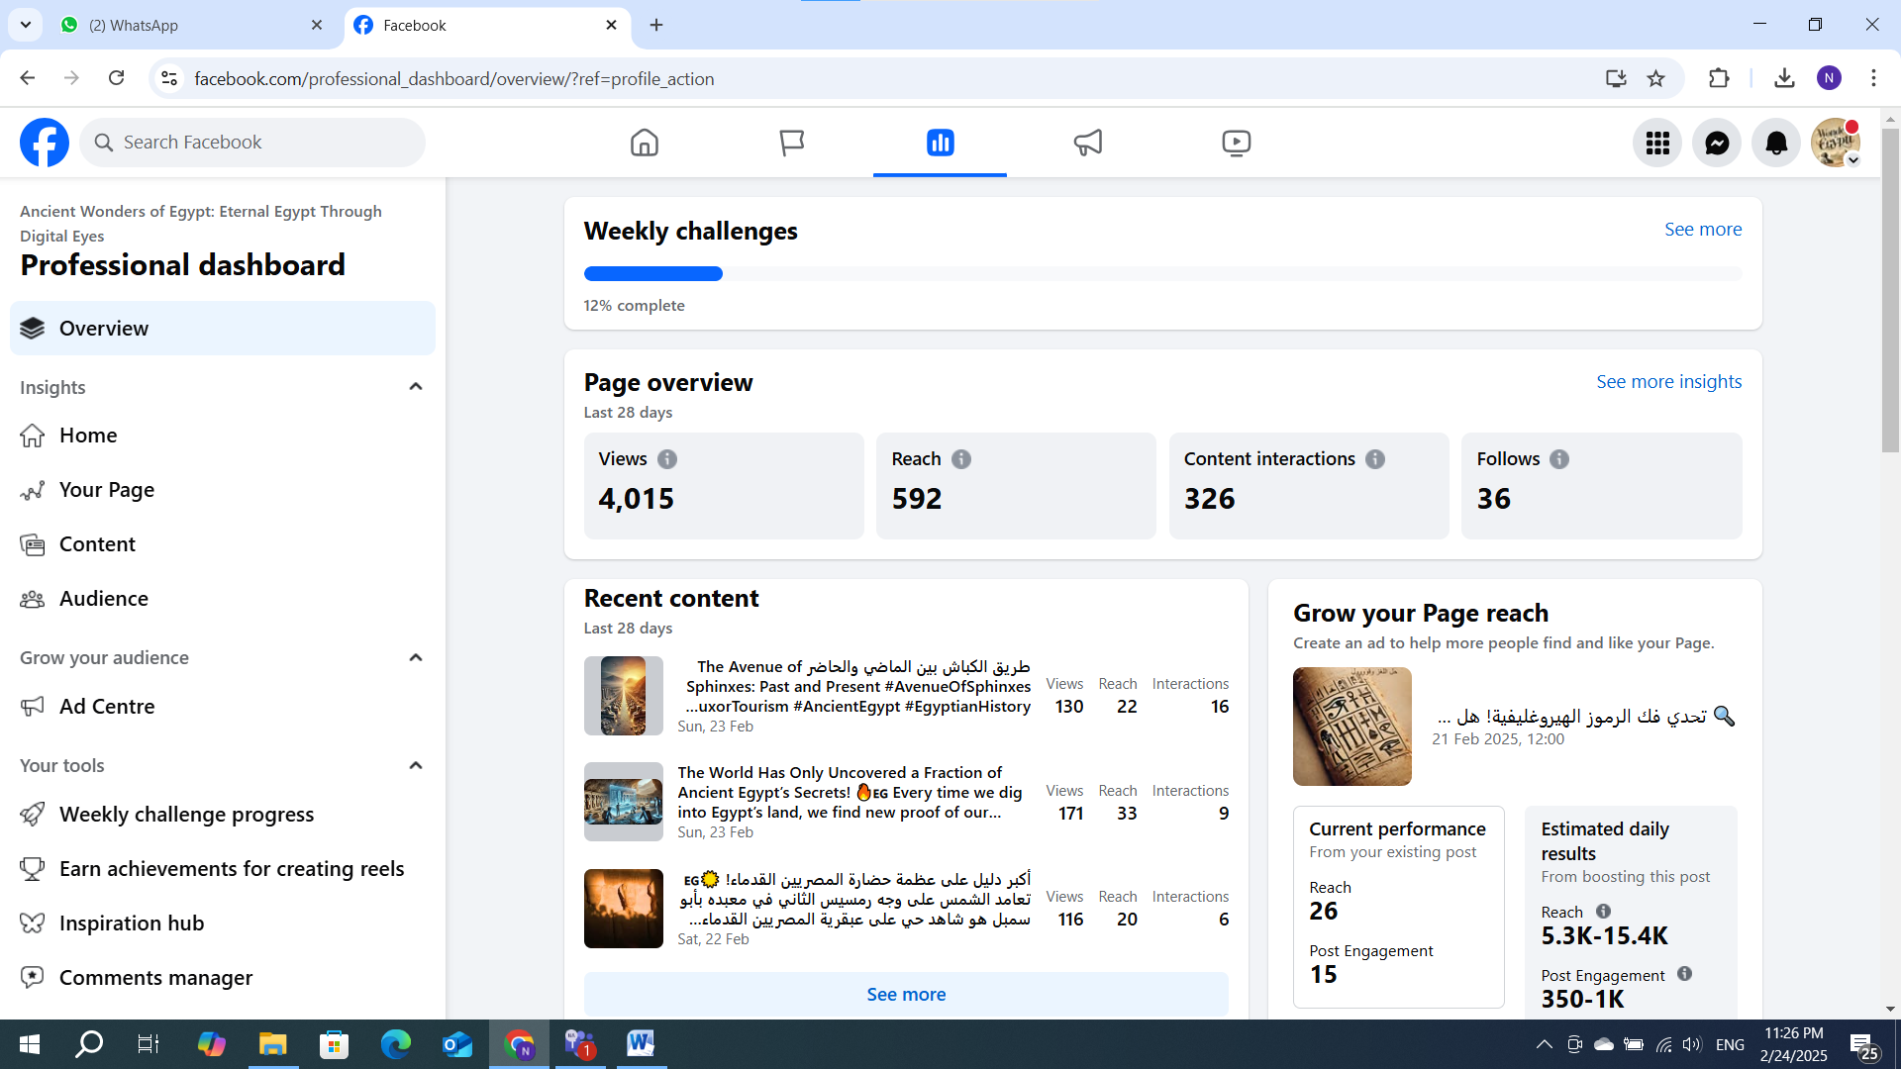

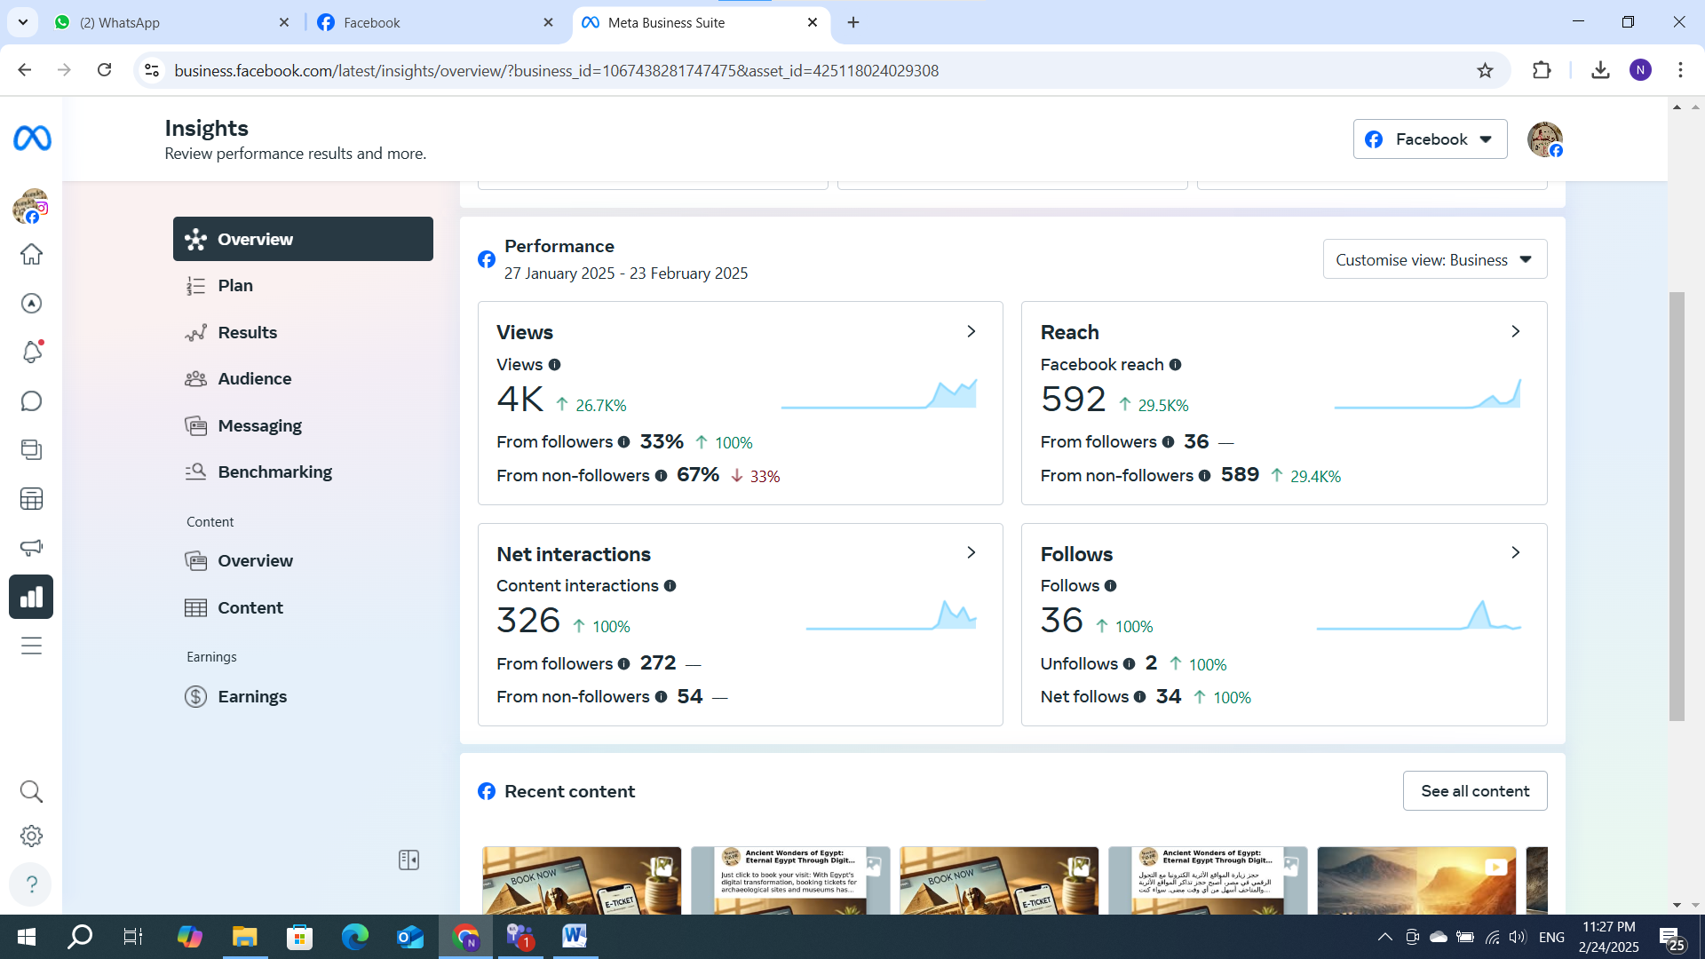

Instagram page

<https://www.instagram.com/wondersofegypt1/>

our insigts:

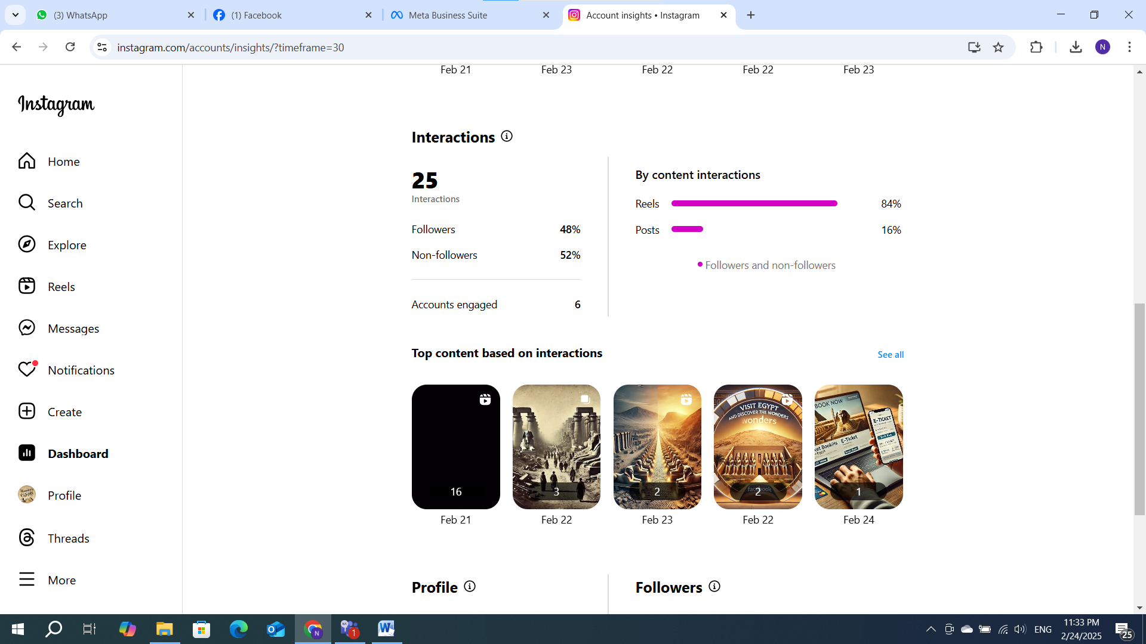

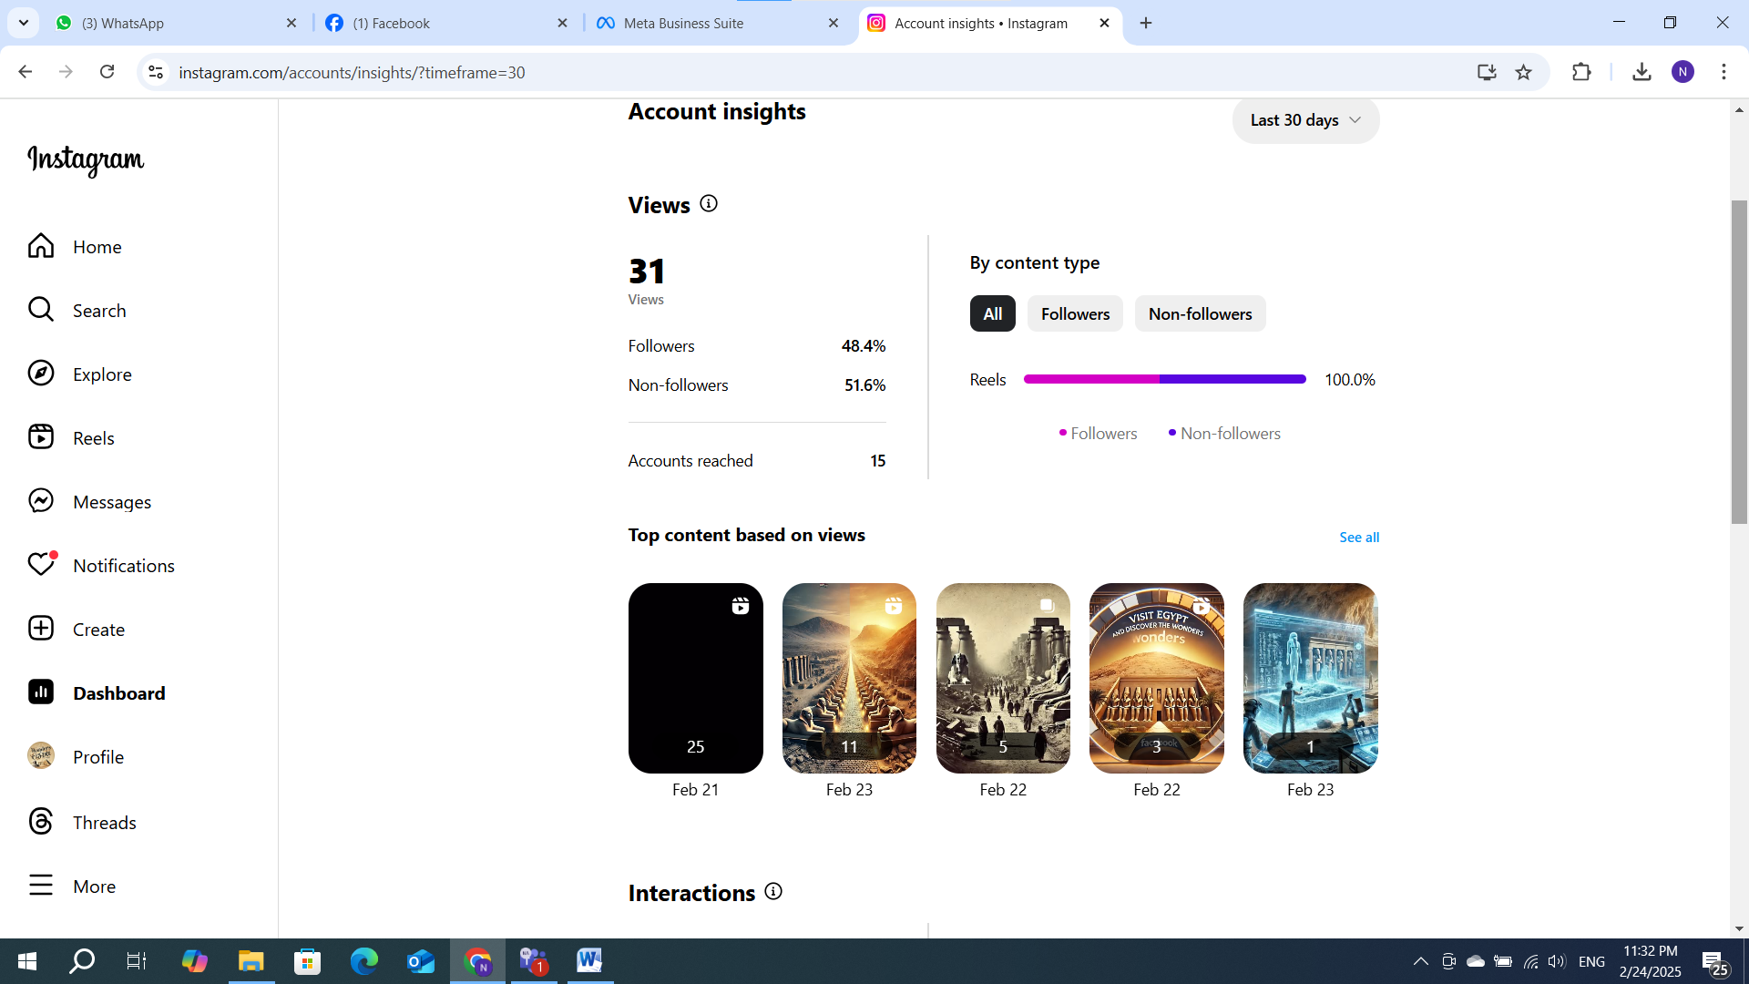

Tik tok account :

<https://www.tiktok.com/@wondersofegyp>

